# Service Now Ticketing for Help with AIQ Issues

**Link to place tickets:** [Report an Issue - ITHelp (service-now.com)](https://coxprod.service-now.com/ithelp?id=incident_record&sys_id=3f1dd0320a0a0b99000a53f7604a2ef9&view=ess)

Please **do NOT** use Charlie or call the main help desk as your ticket could take several extra days to be routed to our team. The link provided above comes directly to the team trained to assist you.

1. Click the link to place a ticket and you should be taken to the “Report an Issue” page:

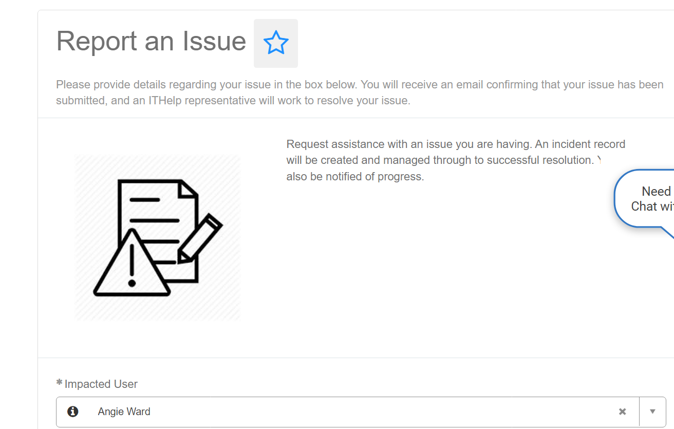

1. Under “What type of issue are you experiencing?”, select **COX MEDIA – Audience/IQ**



For every ticket, fill out the account name, Client ID, Advisr Campaign ID, and a description of the issue. If possible, please include a screenshot of the issue:

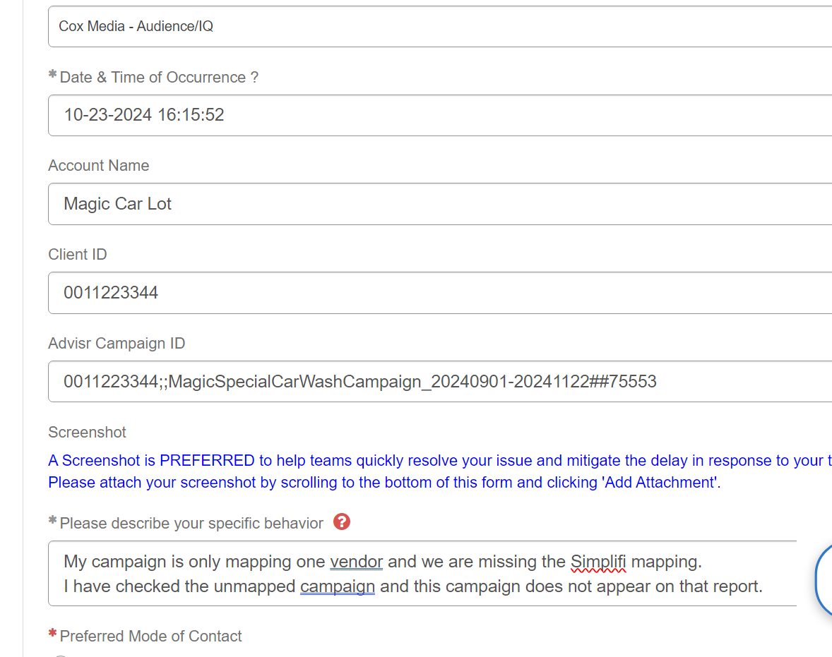



TIPS for Faster Service:

1. Check your unmapped report **BEFORE** placing a ticket. If your campaign is on the unmapped report, it will tell you the reason in “Campaign Unmapped Reason” column.
2. Please include the **run dates of the campaign** if they are not clear from the campaign name.
3. If the issue is a dashboard concern, please include a **link to the dashboard** as well as a screenshot.
4. If it is a reporting concern, include a full screenshot of the **filters** used to pull the report.