Method of Operating Procedure:

Troubleshooting Missing or Mismatched Client IDs

‘Overview
The following Method of Operating Procedure (MOP) is written for CMI System Administrators and describes how to troubleshoot missing or mismatched Advertiser/Agency (Client) IDs.

Terms and Definitions
Term | Definition

Acronyms
Term | Definition
AOS | An Order Management System platform designed by Operative
MOP | Method of Operating Procedure

Table of Contents
Overview 1
Terms and Definitions 1
Acronyms 1
Table of Contents 1
Version Control 2
Authors, Reviewers, and Approvers 2
Change Log 2
Sub Docs Referenced 2
Background 3
Troubleshooting Mismatched or Missing AOS Client IDs 3
Troubleshooting in CRM 3
Accessing Advertiser/Agency Profiles (Accounts) in CRM 3
Identifying and Fixing Client ID Issues using CRM 4
Troubleshooting in Client Creation Service Logs 8
Accessing the Client Creation Service Logs 8
Identifying Client ID Issues using the Client Creation Service Logs 8
Troubleshooting in AOS Master Data Manager 10
Accessing the Client Audit Trail 10
Identifying Client ID Issues using the Client Audit Trail 11
Appendix: Client ID Creation Process Flow 12
Support Contacts 12

Version Control

Authors, Reviewers, and Approvers
Name | Role | Position | Date Reviewed/Approved
Rachel Kubichek | Author | Contract Technical Writer | October 3, 2024
Jeff Miller | Reviewer | Lead Solutions Architect | October 4, 2024
Ben Perry | Reviewer | Lead Solutions Architect
Youshi Patel | Reviewer | Systems Administrator
Susy Schwede | Approver | Senior Director, Business Process Design & Improvement

Change Log
Version # | Date of Change | Changed By | Change Description

Sub Docs Referenced
Name

Background
When a Campaign Onboarding Specialist (Digital Center of Excellence) is preparing to push an order from Advisr to AOS, they must select the AOS Advertiser that matches the Advertiser in the Advisr deal from a dropdown menu in the Advisr interface.
Later, when processing the order in AOS, the user must match the Agency ID to the correct agency in AOS. This is because names can be re-used in AOS and it is possible to have two or more agencies with the same name, but different IDs. (For example, names may be re-used in different markets.)
When users cannot find or identify the appropriate Advertiser/Agency ID, they may submit a request to Joey Arbuckle. Joey will forward any pertinent requests on to the CMI System Administrators. The following MOP details how CMI System Administrators should troubleshoot issues like these.

Troubleshooting Mismatched or Missing AOS Client IDs
If you receive a request to fix a Mismatched or Missing AOS ID from Joey Arbuckle, you have three places you can investigate to identify the root of the problem:
- CRM
- The Client Creation Service logs
- The AOS Master Data Manager (MDM)
If you do not identify an issue in one location, investigate the other locations for other possible issues.

Troubleshooting in CRM

Accessing Advertiser/Agency Profiles (Accounts) in CRM
- Login to Oracle CRM.
- Click the 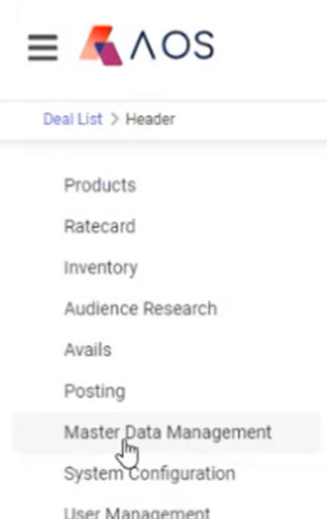 icon at the top left of the CRM interface.
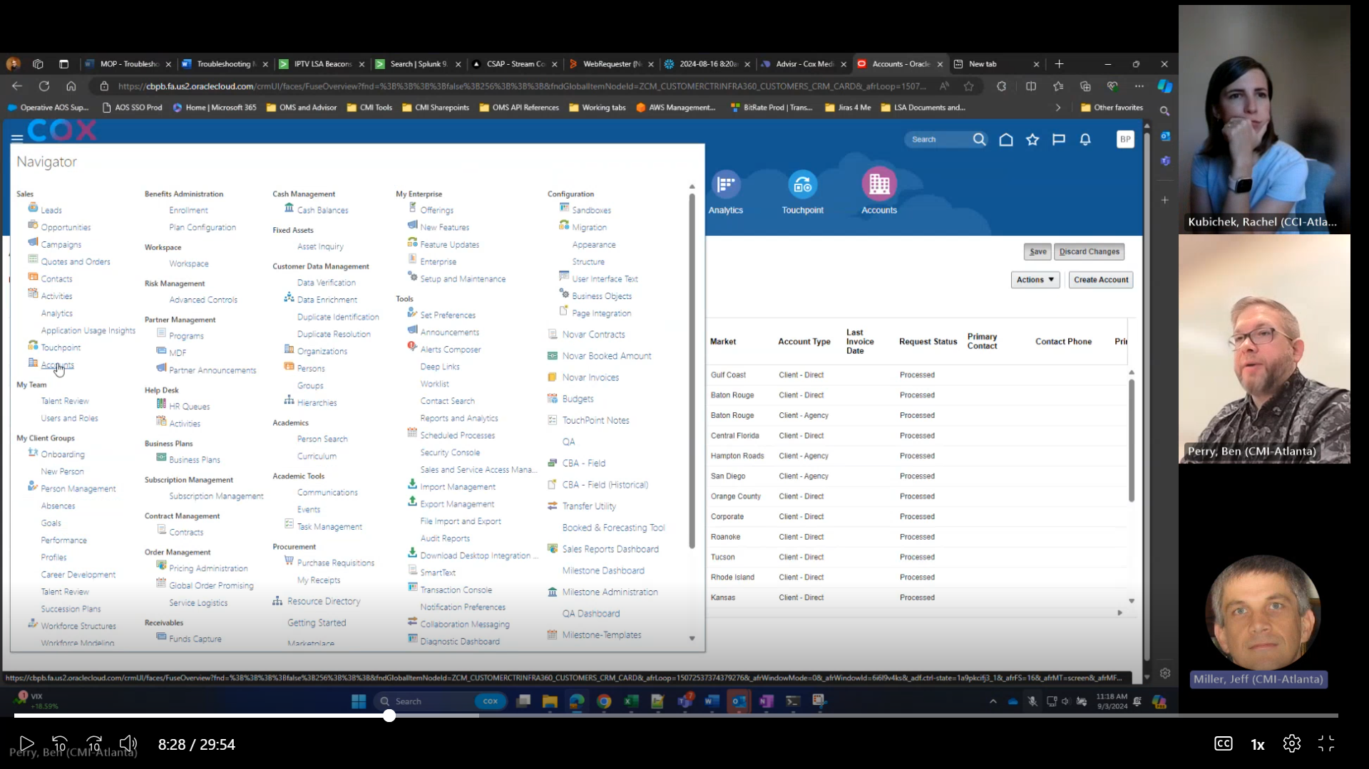
- Click Accounts.
- In the window that appears, search for the Advertiser/Agency you want to find. For example, Braintrust Marketing.
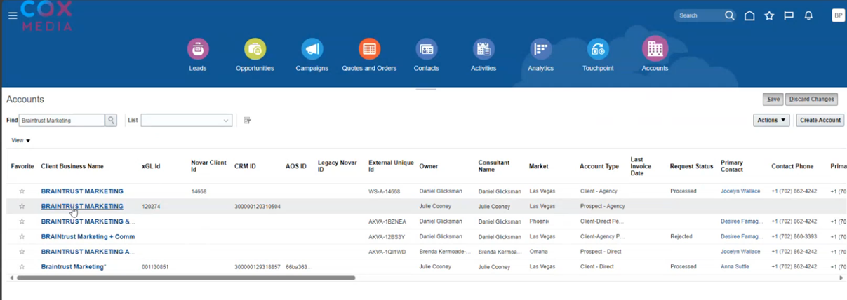

Identifying and Fixing Client ID Issues using CRM
In the example above, three Braintrust Marketing advertisers/agencies appeared when the user performed a query for Braintrust Marketing. One of these profiles has no xGL ID nor CRM ID; the second has an xGL ID and a CRM ID; and the third has an xGL, CRM, and AOS ID.

Missing CRM ID
If an Advertiser/Agency has no CRM ID, it will not have an xGL ID nor an AOS ID. If you want to add a CRM ID to an Advertiser/Agency (and thereby push the Advertiser/Agency through to AOS),
- Click the name of the Advertiser/Agency (as shown in the CRM screenshot above).
- In the window that appears, click the Profile tab on the lefthand side.
- Scroll to the CRM ID field and verify that it is blank.
- Scroll to the Additional Information field and type a period or the word, Touch, in the Notes field.
- Click Save. In the next 5 minutes, the CRM ID will appear.
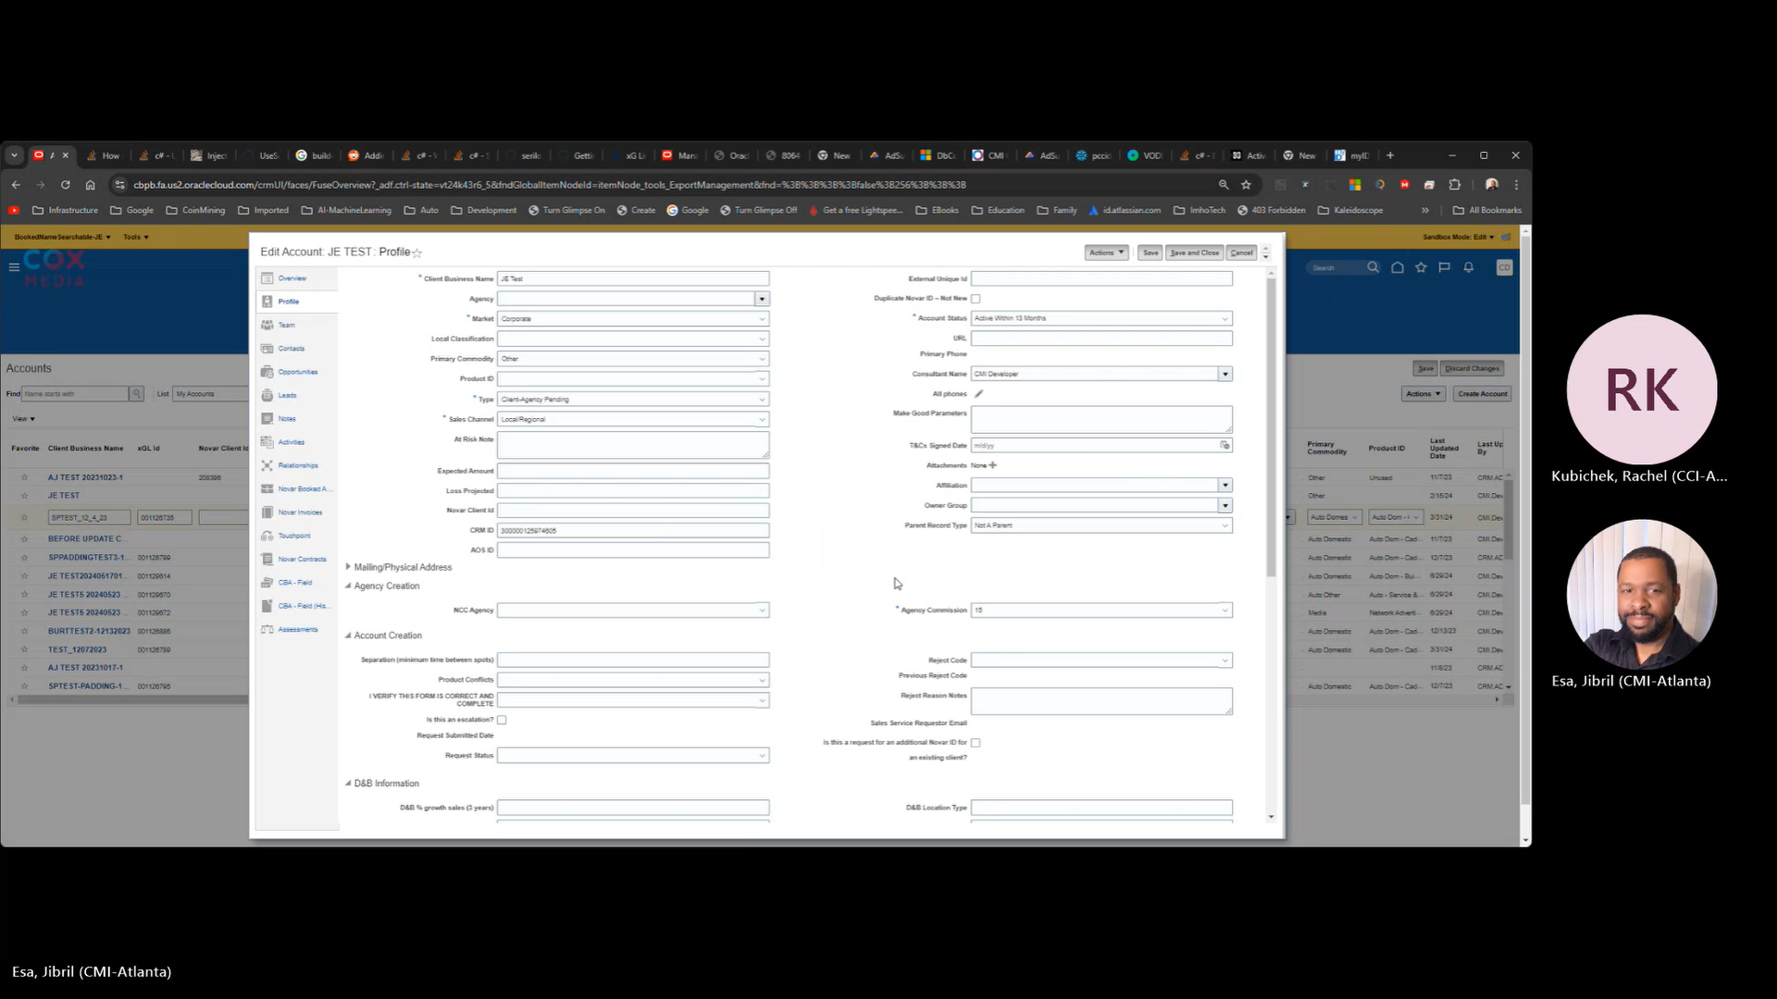

Missing xGL ID
If an Advertiser/Agency has a CRM ID but no xGL nor AOS ID and you want to add an xGL ID (and thereby push the Advertiser/Agency through to AOS),
- Click the name of the Advertiser/Agency in CRM.
- In the window that appears, click the Profile tab on the lefthand side.
- Scroll to the Interface Information section and verify that the xGL ID field is blank.
- If the xGL ID field is blank, open the RR Interface Status dropdown menu and select SEND_TO_ROADRUNNER.
- Scroll to the Additional Information field and type a period or the word, Touch, in the Notes field.
- Click Save. In the next 5 minutes, the xGL ID will appear.
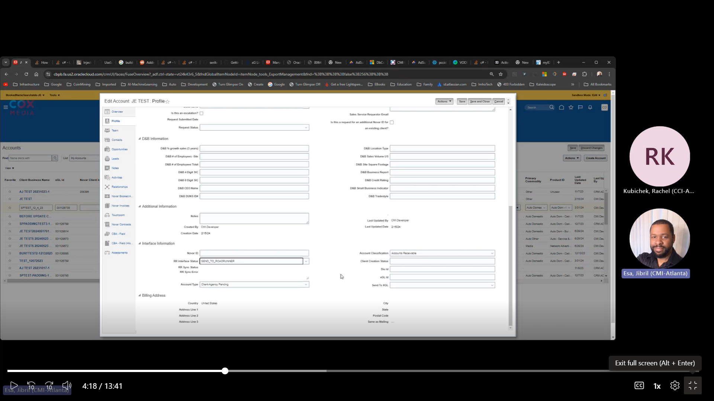

Missing AOS ID
If an Advertiser/Agency has CRM and xGL IDs, but no AOS ID and you want to push the Advertiser/Agency through to AOS,
- Click the name of the Advertiser/Agency in CRM.
- In the window that appears, click the Profile tab on the lefthand side.
- Scroll to the Interface Information section and change the RR Interface Status to Processed.
- Scroll to the Additional Information field and type a period or the word, Touch, in the Notes field.
- Click Save. In the next 5 minutes, the Client Creation Service will push this Advertiser/Agency on to AOS and create the AOS ID.
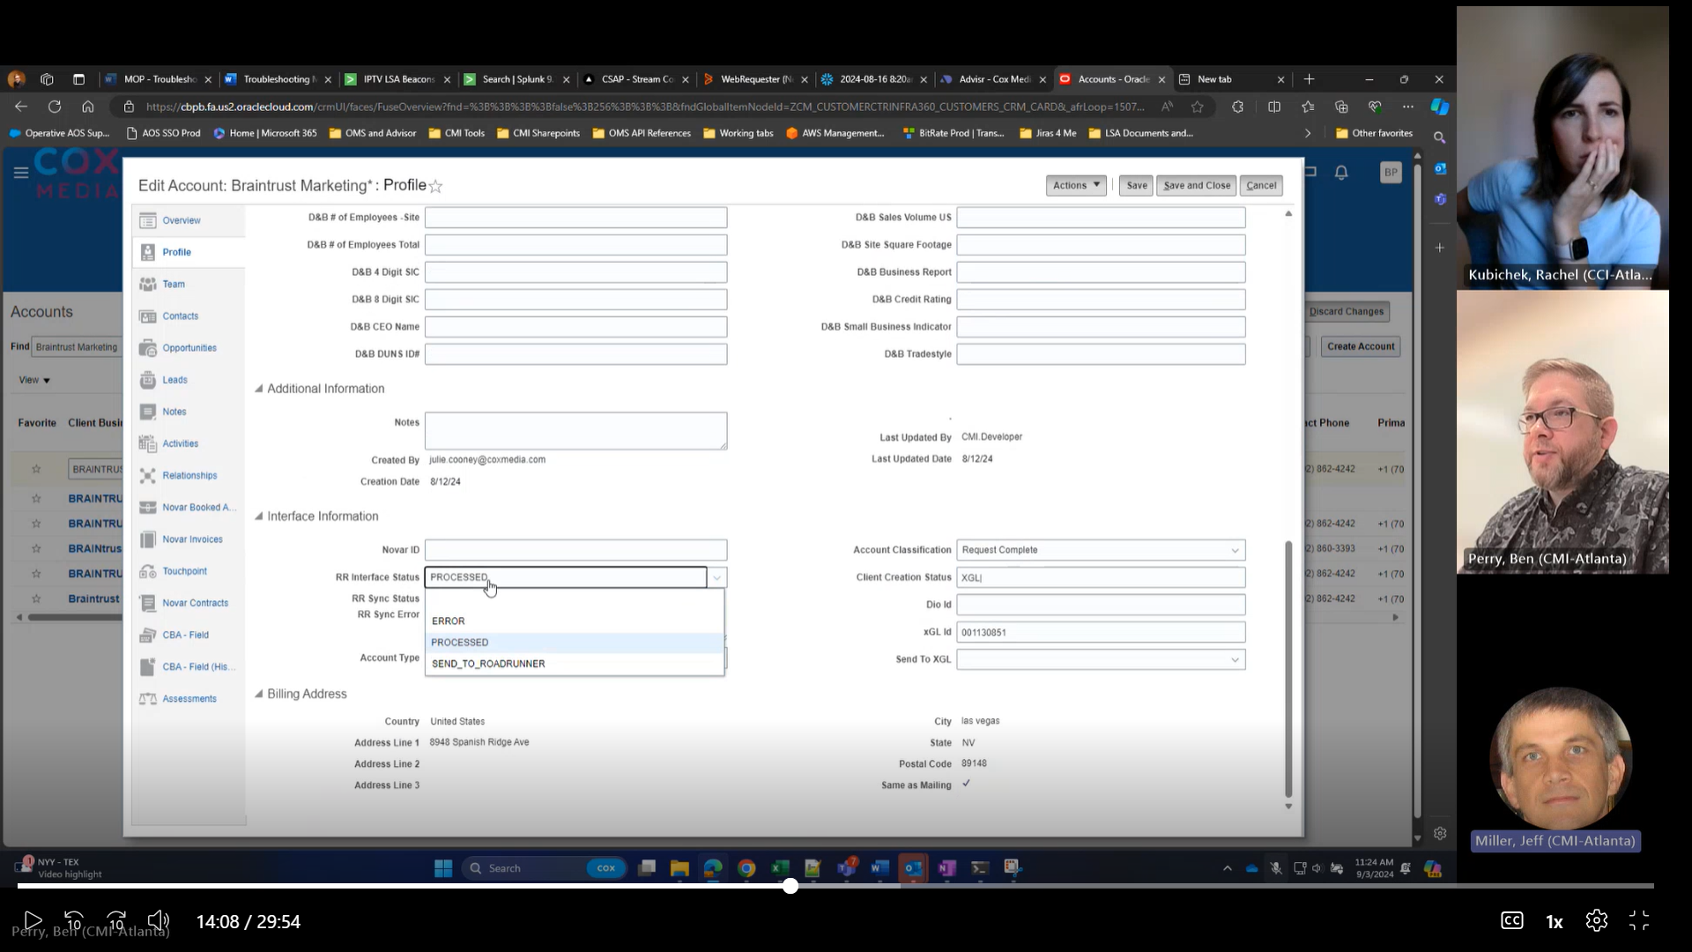

Mismatched ID in AOS and CRM
If an Advertiser/Agency has been pushed all the way to AOS. If there is a mismatch between the CRM Advertiser/Agency profile or ID and the AOS Advertiser Agency profile or ID,
- Compare the CRM/AOS profiles against each other:
- In CRM, note the listed xGL ID of the Advertiser/Agency (highlighted in blue in the example below).
- Login to AOS and navigate to > Master Data Management.
- Select either the Advertiser or Agency tab, whichever is appropriate.
- Locate and select the Advertiser or Agency using the Advertiser Name or Agency Name search fields.
- Navigate to System Mapping.
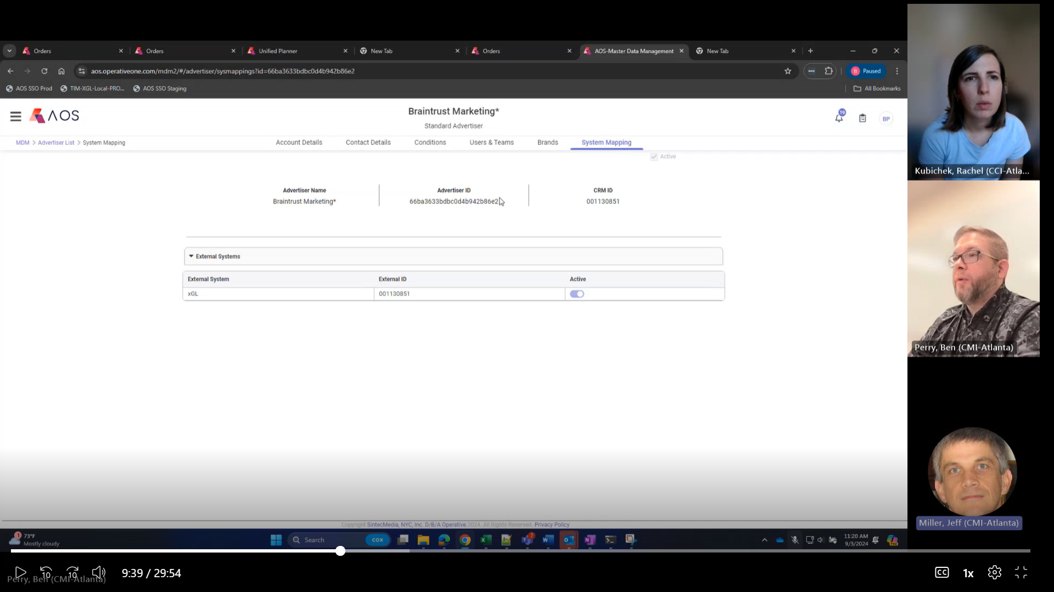
- The CRM ID (highlighted in blue above) in AOS should be the same as the xGL ID in CRM (highlighted in blue in the previous screenshot).
- The Advertiser ID (highlighted in pink above) in AOS should be the same as the AOS ID in CRM (highlighted in pink in the previous screenshot).
- The External ID shown for the External System (xGL) should also be the same as the xGL ID in CRM and the CRM ID in AOS.
- If there are conflicts between the Advertiser/Agency IDs in AOS and CRM, adjust the IDs in CRM to match the Advertiser/Agency in AOS. If the CRM ID in AOS and the xGL ID do not match, it may be better to inactivate the client in AOS and create a new AOS client to match CRM. This necessitates either opening a ticket with Operative OR using the AOS API to assign a specific xGL ID to the client.
REMEMBER: CRM is the ultimate source of truth for all Client IDs.

Troubleshooting in Client Creation Service Logs

Accessing the Client Creation Service Logs
To access the Client Creation Service Logs,
- Open Windows File Explorer and navigate to: \\catl0pwas14896\Aos-clientcreation-logs.
- Locate and open the appropriate log file for the time frame you are investigating. A window like the following will appear:
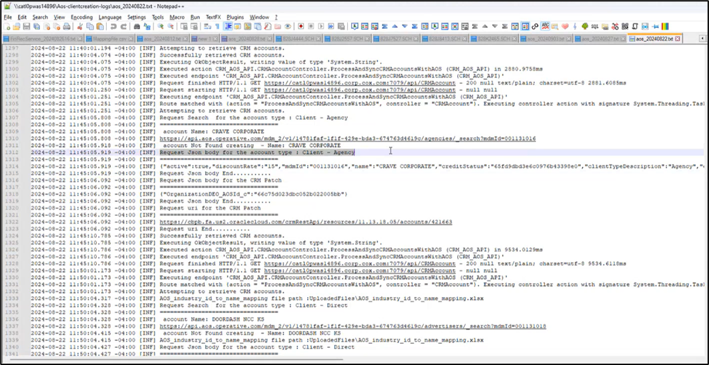

Identifying Client ID Issues using the Client Creation Service Logs
The Client Creation Service Logs can help you identify if or when changes were made to an Advertiser/Agency ID.
In the example below, the log shows a request coming in for an Agency called “Crave Corporate.” (Account types will be either Client – Agency, which is an Agency, or Client – Direct, which is an Advertiser.)
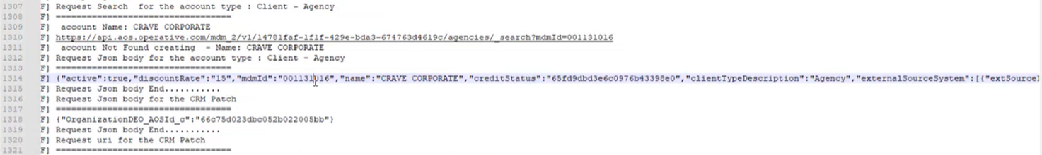

In this example, the API is checking to see if this MDM ID (xGL ID) exists in AOS. The response is that, yes, the xGL ID exists and the status is active. The API then returns the AOS ID.
To troubleshoot ID issues between the Client Creation Service log and AOS,
- Login to AOS and navigate to > Master Data Management.
- Select either the Advertiser or Agency tab, whichever is appropriate.
- Locate the Advertiser or Agency using the Advertiser Name or Agency Name search fields.
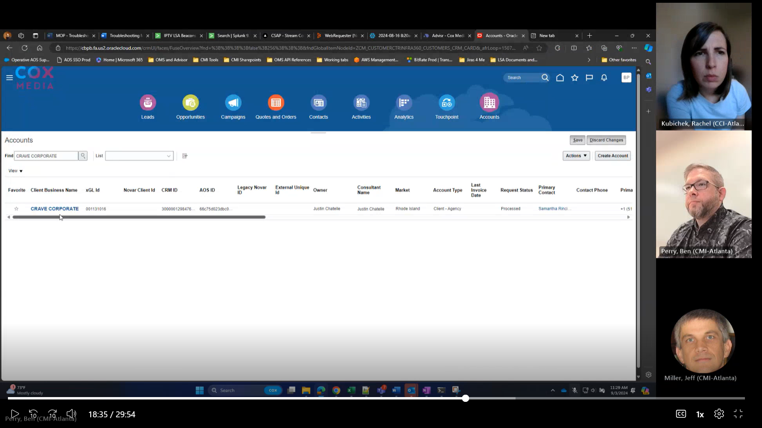
- Compare the AOS ID in AOS against the AOS ID listed in the Client Creation Service log.
- Compare the xGL ID in AOS against the MDM ID listed in the Client Creation Service log.
- Look for any messages within the Client Creation Service log that might indicate changes that have been made to the IDs. It can be helpful to see the values that were pushed to AOS when the client was created because it can show if the client was created with the correct/incorrect name and if someone possibly edited it later. Reading the logs in conjunction with the AOS Audit Trail for an Advertiser/Agency can be helpful.

Troubleshooting in AOS Master Data Manager

Accessing the Client Audit Trail
To access the AOS Master Data Manager (MDM),
- Log in to AOS.
- Click the icon at the top left of the AOS interface.
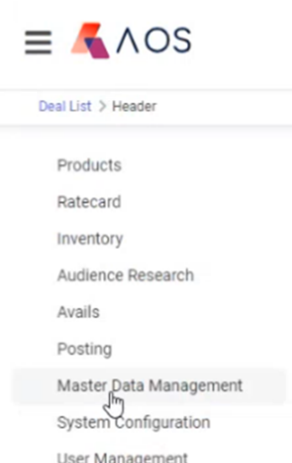
- Click Master Data Management.
- Click the appropriate tab (either Advertiser or Agency).
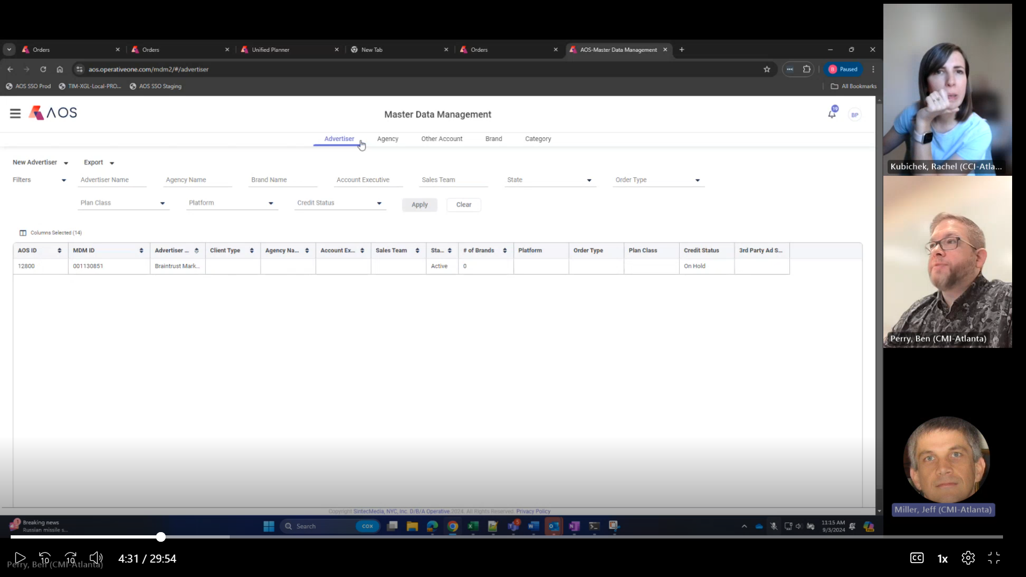
- Locate and select the Advertiser or Agency using the Advertiser Name or Agency Name search fields.
- In the window that appears, click the Audit Trail button.
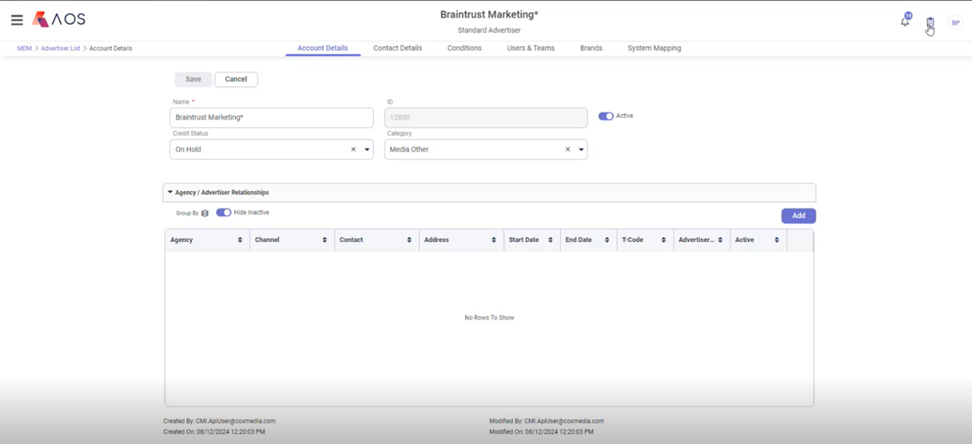
- In the window that appears, select the desired date range.
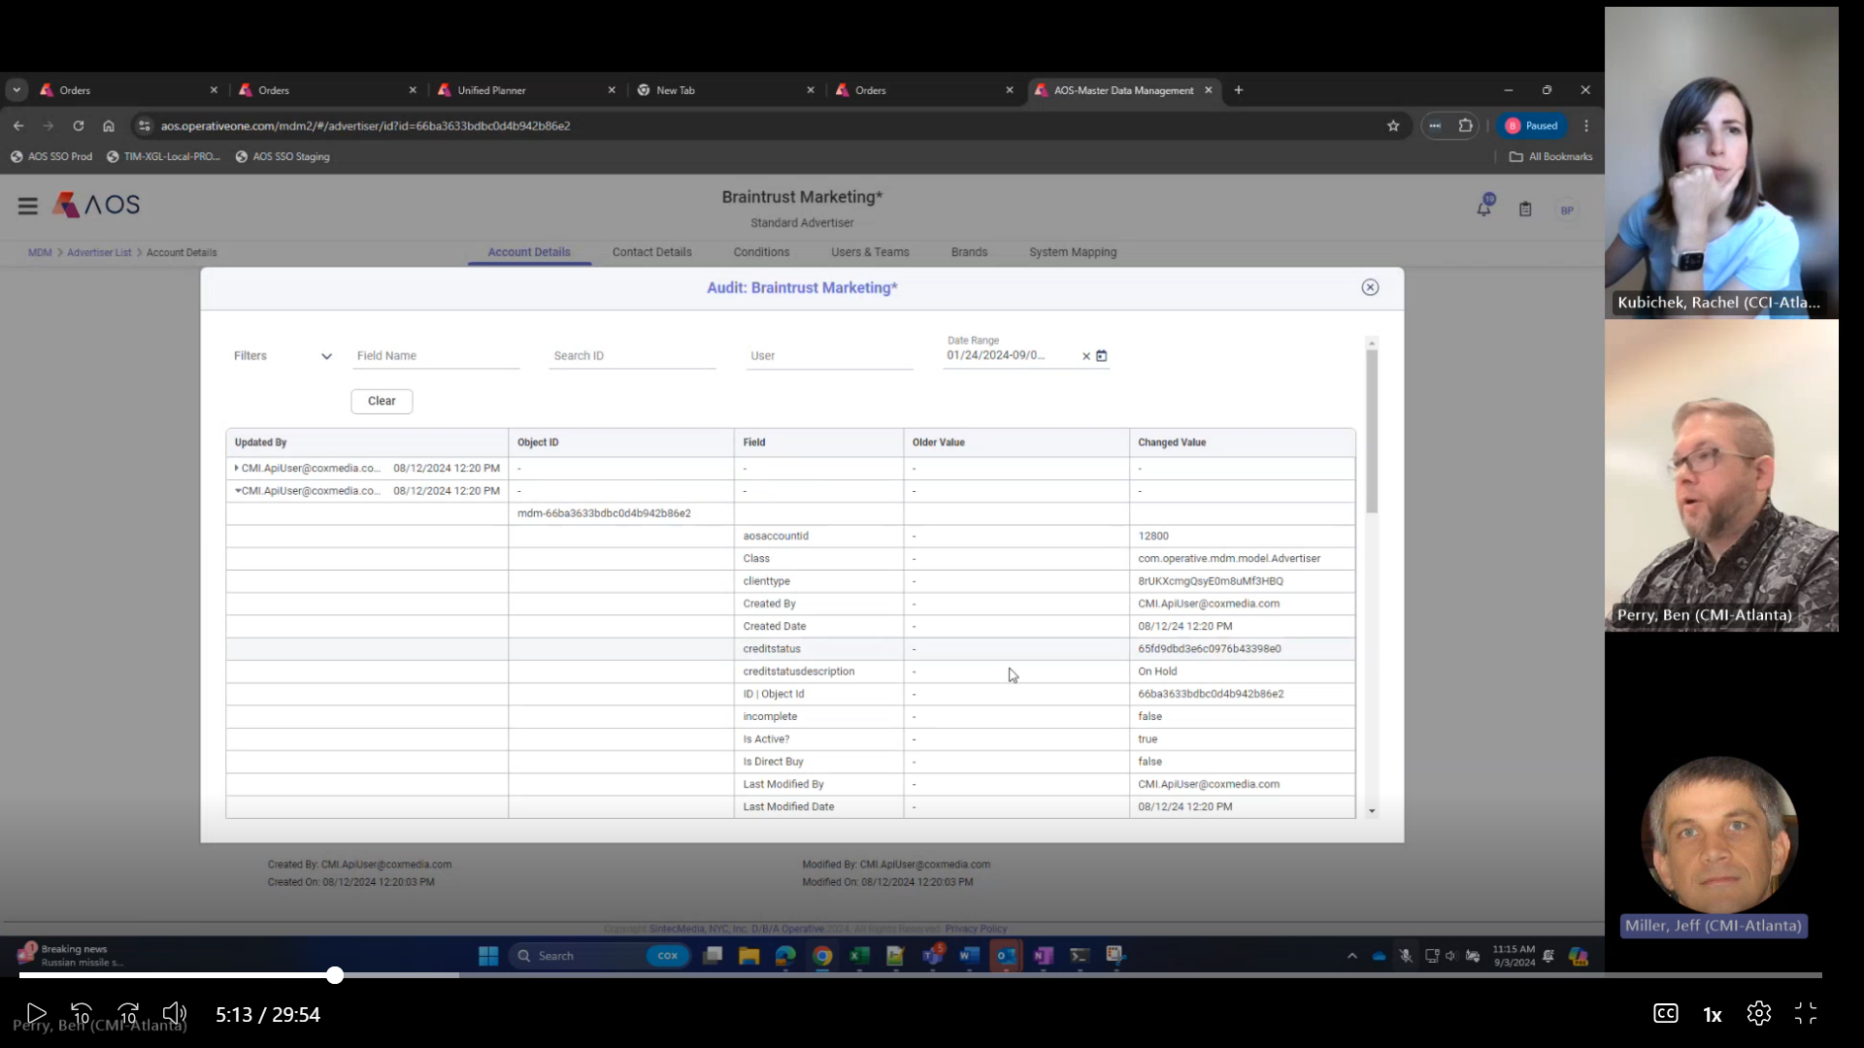
- Open the items in the Updated By column to view the audit trail of the Advertiser/Agency.

Identifying Client ID Issues using the Client Audit Trail
Look for actions that might have contributed to a missing AOS ID. Below are frequently helpful pieces of information:
“Last Modified By” | Generally, “CMIAPIuser@coxmedia.com” (the CMI Client Creation Service) should be the only entity modifying Client IDs. If another username appears here, reach out to the individual/entity and ask why they changed the ID. Explain that changing the Client ID in AOS creates a mismatch between the root Client profile in CRM and AOS, which can create confusion. Only the CMI Client Creation Service or CMI System Administrators should change Client IDs.  EXCEPTION: Accounts Receivable (AR) names will frequently appear in the Last Modified By field. This is usually because they had to change the credit status of a client. This is acceptable and necessary; however, AR should never modify the Client ID.
Original Values | Helpful to compare against new values.
AOS ID | Helpful to compare against the Original Values.

Appendix: Client ID Creation Process Flow
Client Creation is initiated in CRM. The process below must complete properly for a client to be available to Advisr and AOS.
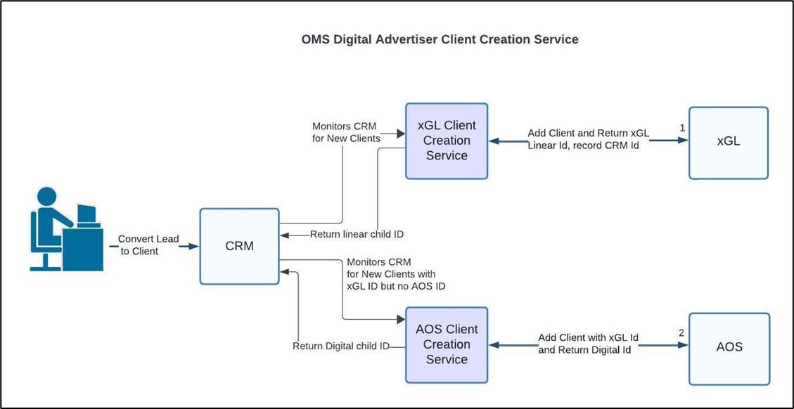

Support Contacts
For issues with . . . | Contact . . . | Contact Information
AOS | Operative support portal | https://operative.my.site.com/OPERATE/login via CMI Tech Support
xGL | Dianna Rizzo | Dianna.rizzo@coxmedia.com
CRM | Angie Ward | Angie.ward@coxmedia.com
Client Creation Service | Jibril Esa and Shiv Patel | Jibril.esa@coxmedia.com and shiv.patel@coxmedia.com

